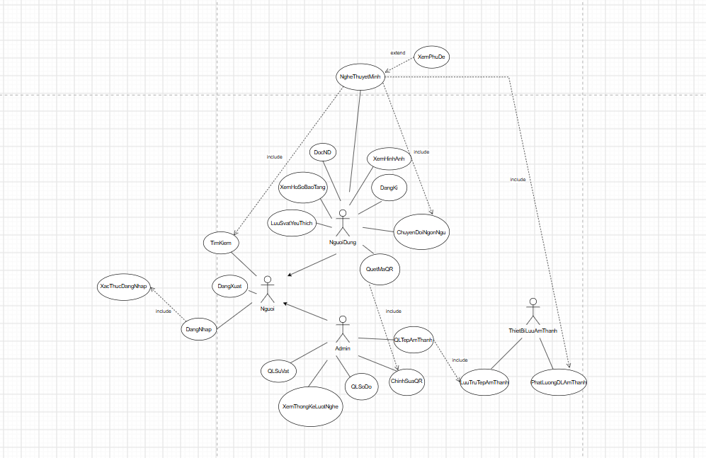

Link chỉnh sửa: https://drive.google.com/file/d/1f8J-maKBNPGQur6veM6B-v2mSal84Ssz/view?usp=sharing

